TITLE PAGE

MUNICIPALITY OF XXXX

Acknowledgements

The Sustainable Infrastructure Replacement Plan (the Plan) was prepared by XXX. This project has significant input from Local Government Departments and consultants, specifically:
Data Contributors/Technical Reviewers
- XXX Deputy Director of Engineering
- XXXX, Manager of Accounting,
- XXX, GIS Technician
- XXX, Chief Administrative Officer, XXX LG
- XXX, CPA CGA, Director of Finance, XXX LG
- XXX MCIP, RPP, Director of Development Services, XXX LG
Consultants
- XXXX
- XXXX
- XXXX

Contents
Acknowledgements 2
Executive Summary 6
Scope of Work and Limitations 8
SECTION A: ASSET MANAGEMENT IN LOCAL GOVERNMENT 12
Purpose of the Plan – Alignment of Long-Term Funding 13
Introduction to Asset Management 13
Asset Management Policy 14
Council Direction – Asset Management 14
Asset Management Program Component 15
SECTION B: OVERVIEW OF ASSET INVENTORY 16
Inventory Valuation 17
Inventory Consumption 17
Summary of Asset Condition Assessments 18
SECTION C: INFRASTRUCTURE FUNDING 19
Annual Funding Levels 20
Summary of Reserves (Accumulated Funding) 20
Sustainable Annual Funding vs Actual 20
Accumulated Infrastructure Funding Gap 21
SECTION D: MODELLING 22
Infrastructure Replacement Forecast 2023-2122 23
Reserves & Debt Forecast 2023-2122 23
SECTION E: RECOMMENDATIONS 25
Funding Recommendations 26
Policy Recommendations 27
Life-cycle Costing Policy Recommendations 27
Investment Recommendations 29
SECTION F: DETAILED INVENTORY OF INFRASTRUCTURE 31
Nature Assets 32
Land and Park Inventory 32
Rivers, Creeks, Streams 33
Trees 34
Foreshore 34
Park Structures 35
Park Structures Inventory 35
Park Structures Condition Assessment 35
Park Structures Spending Forecast 35
Vehicles 36
Vehicles Inventory 36
Vehicles Condition Assessment 36
Vehicles Spending Forecast 36
Buildings 38
Buildings Inventory 38
Buildings Condition Assessment 38
Buildings Spending Forecast 39
Road Infrastructure 40
Road Inventory 40
Road Spending Forecast 41
Drainage 43
Drainage Inventory 43
Drainage Condition Assessment 43
Drainage Spending Forecast 43
Sanitary Sewer Infrastructure 45
Sanitary Sewer Inventory 45
Sanitary Sewer Condition Assessment 46
Sanitary Sewer Spending Forecast 46
Water Infrastructure 47
Water Infrastructure Inventory 48
Water Infrastructure Condition Assessment 48
Water Infrastructure Spending Forecast 48
GLOSSARY OF TERMS 50
APPENDIX A: BASIS FOR CONDITION ASSESSMENT 51
APPENDIX B: SENSITIVITY ANALYSIS 53
Appendix C: SUMMARY OF RECOMMENDATIONS 54
Appendix D: USEFUL LIFE ASSUMPTIONS 55
List of Figures & Tables 56

Executive Summary

Introduction
- Use this section to introduce the organization/Local Government including jurisdiction size, population, age, history, and connection to Indigenous history.
- Introduce the reader to the duty of stewardship of public assets.
- Highlight any governance decisions that have led tot his product.
- Identify why this report is relevant to the organization at this point in its history.

Purpose of this Plan
This Plan was primarily developed to support sustainable service delivery of the Local Government’s capital services. In order for the Local Government capital services to remain sustainable, appropriate funding must be dedicated for infrastructure replacement. This Plan estimates sustainable funding levels by modelling estimated replacement costs over a 100-year timeframe.
Key Findings
This Plan has the following key findings:
- Inventory Valuation: The estimated replacement costs the Local Government’s Sanitary Sewer Assets are approximately $20.1M.
- Infrastructure Condition: Overall, the Local Government’s assets are in good condition as the infrastructure is relatively new. Assets are estimated to be 55% consumed on average.
- Annual funding levels: Annual funding levels are currently not sustainable. Annual funding is estimated to be approximately 43% sustainable. Modelling indicates that current funding levels could result in a $14.3M 100-year funding gap. 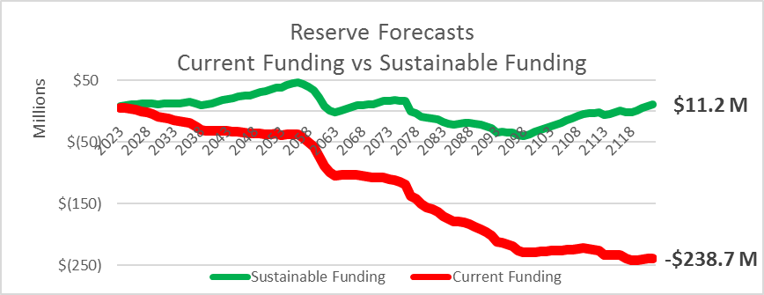
100-Year Funding Gap: $249.9M

Figure 1: 100 Year Funding Gap Forecast

- Accumulated Infrastructure Funding Gap: The Local Government’s Infrastructure Funding Gap is estimated to be $10.6M. Since depreciable assets are estimated to be 55% consumed, sustainable reserve levels would be 55% x 20.1M = $11.1M. The Local Government has approximately 0.5M set aside for infrastructure replacement leaving a 10.6M estimated Accumulated Infrastructure Funding Gap.
- Natural Assets: The Local Government has a rich inventory of natural assets including parkland, trees, creeks, and shoreline. For instance the Local Government has approximately XX.XKM of creeks that provide drainage services. The annual lifecycle costs of grey infrastructure alternatives to creeks in the Local Government is estimated to be XXXk per year.
- Sensitivity Analysis: A sensitivity analysis was conducted to help authenticate the broad findings of this review. Broad findings include estimated annual sustainable funding, annual funding gap, and the cumulative infrastructure funding gap. Overall, the sensitivity analysis confirms that a significant funding gap exists that will need to be addressed by the Local Government now or in the future.
Key Recommendations
The Plan contains the following key recommendations:
- Increase funding to sustainable levels:
  - Dedicate $XXXX of annual casino revenue toward infrastructure replacement reserve funding.
  - Increase Sewer Utility Revenue by X% per year for X years for sanitary sewer infrastructure reserve funding. The estimated impact to the average residential property is a $XX increase in each year for the X years.
  - Increase property taxes by X% per year for X years for general infrastructure renewal reserves funding. The estimated impact to the average residential property would be a $XX increase each year to the average residential property.
  - Convert debt servicing budgets to infrastructure replacement reserve funding when debt retires.
  - Utilize Non-Market Change Revenue to increase infrastructure replacement reserve funding until the annual funding gap is closed.
- Integrate Lifecycle costing in Local Government decision making in the following ways:
  - Amend the Local Government’s Purchasing Policy XXX to consider lifecycle costing when evaluating procurement decisions.
  - Amend the Local Government’s Financial Plan Policy, found within the Financial Plan Bylaw, to require a lifecycle costing analysis to be conducted when new capital expenditures are considered.
  - Require a lifecycle costing analysis to be conducted for Council to consider when considering rezoning applications.
- Align long term cash flows with investment portfolio/horizon

Scope of Work and Limitations

Scope of Work
The Local Government was engaged to provide the following services:
- Prepare a professional report that details:
- Estimated replacement costs by asset class,
- Forecasted infrastructure replacement costs over selected time horizon,
- Analysis of current funding vs. sustainable funding,
- Quantification of annual funding gap or surplus,
- Sensitivity analysis that models changing of key forecasting variables,
- Forecasted reserve balances and debt servicing costs,
- Executive summary outlining key findings and key recommendations,
- Policy recommendations,
- Condition assessments based on modified American Society of Civil Engineers alpha numeric system,
- Integration of YourCity key performance indicators.
- Provide a financial modelling database.
- Prepare a PowerPoint presentation.
- Attendance at a Council meeting to present findings.

Key Assumptions
Capital grants: Forecasts do not include any potential conditional grants awarded by senior levels of government. However, forecasts do include ongoing unconditional Federal Gas Tax payments.

Capital Service Continuity: For modelling, it was assumed that the Local Government would want to continue with the current capital services and capital service levels. The Local Government may choose not to replace some of its capital or reduce / increase capital services. Such decisions could materially impact modelling.

Casino Revenue: Using a weighted-average Council dedicated XX% of casino revenues toward capital in the 2022-2026 Financial Plan. For this reason, the Plan assumed XX% of casino revenue reserves and 42% of future proceeds will be dedicated to infrastructure replacement. Council may choose to increase or decrease this proportion, however this would materially impact modelling.

Culvert Unit Rates: The unit rates for culverts can vary significantly by diameter. As the length of the culvert by diameter size data was not available, modelling was prepared using the unit rate for a 600mm diameter. Local Government staff indicated that most driveway crossing diameters were 450mm, and road crossing diameters are 600mm. Therefore, this assumption is expected to be slightly conservative.

Curb and Gutter Age: Precise in-service date data was not available for curb and gutter. For modelling purposes, the Plan assumed curb and gutter age was equal to adjacent road base age.

Climate change: The Plan did not examine the risk or impact of climate change to the Local Government’s infrastructure or private property. Further review, funding, and staff capacity would be required should Council or the community wish to understand the broader implications of climate change risk on the community.

Existing Capital Only: The Plan does not model anticipated growth in infrastructure requirements. Forecasts are based on the replacement of existing municipal infrastructure only. For instance, these forecasts have not contemplated the increased capacity required to support future densification or development. The Plan has not anticipated potential future decisions to increase capital service levels. Many of the Local Government’s Master Plans do anticipate growth. Adoption of the sustainable asset management recommendations in the Plan, such as Funding Recommendation #1 and Policy Recommendations #2 and #3, will support the sustainable funding of future growth.

Inflation: Modelling has been prepared using 2022 values. No inflationary factor has been applied to forecasted replacement costs. As unit costs are likely to escalate, the Local Government should consider applying an annual forced growth increase to recommended investment levels.

Infrastructure Replacement Standards: Forecasts are prepared with the assumption that infrastructure will be replaced at the same standard that currently exists. However, some of the Local Government’s infrastructure does not meet existing standards, for example, some of the Local Government’s sidewalks are 1.5m in width and would need to be widen to 2m to meet improved standards.

Investment Revenue: Modelling has integrated a XX% investment return rate. This assumption may be conservative in the long run. Since its inception, the Municipal Finance Authority Money (MFA) Market Fund has had a historical return of 3.59%. However, the return has been 1.05% for the past 5 years. Yields have recently swung from a historically low yield of less than 0.25% to a current yield of above 1.00% is expected to continue to rise. Additionally, the Local Government can choose to diversify its long-term cash flows in high-yielding funds such as the MFA’s bond fund. This fund has returned over 5% on average since inception, with a 1.43% 5-year average. The MFA has recently introduced a new Diversified Multi-Asset Class Fund, which is exposed to market equities and is expected to produce high yields over the long term. Doubling forecasted investment returns from 1.50% to 3.00% could increase modelled investment returns from approximately $12M to $60M+ over the next 100-years.

Parkland Assessed Values: Parkland is assessed and valued using an institutional park rate applied by BC Assessment.

Replacement Cost Accuracy: Unit rates were developed to estimate overall replacement costs and to develop a long-term sustainable funding model. No Class-D or above construction estimates have been prepared. Therefore, none of the spending forecasts should be utilized to prepare a capital plan. Spending forecasts demonstrate an overall funding level likely needed to support the ongoing replacement of existing infrastructure. Replacement cost accuracy will differ between asset class and subclass:
- Roads, storm sewer, sanitary sewer: assumed zero bedrock removal, depth of mains 1 to 2.5 meters, nothing deep, no bypass pumping, or removal of existing mains is assumed.
- Buildings: based on most recent replacement cost appraisals available. Capital maintenance of subcomponent was estimated using industry accepted best practice of percentage of replacement cost componentization.
- Land: based on 2022 Assessed Valued published by BC Assessment.
- Vehicles and Equipment: based on most recent vehicle equipment plans prepared by Local Government staff.
- Park structures: based on most recent appraisal conducted, when available. Based on inflated historical cost when not available.

Sidewalk Age: In-service date data was not available for sidewalks, therefore it was not possible to calculate a precise asset consumption based on estimated useful life. Modelling in the Plan assumed that sidewalks were 50% consumed.

Undedicated Reserves: The Local Government has not dedicated accumulated reserve balances and annual funding levels by asset class. Therefore, to estimate the Local Government’s accumulated infrastructure funding gap and the annual funding gap, the Plan apportions funding based on a proportion of replacement cost. However, the Local Government may choose to dedicate or commit these funds differently.

Works of Art: The Local Government manages and controls various works of art and non-operational historical, and cultural assets, including buildings, artifacts, paintings, and sculptures located at Local Government sites and public display areas. These various works of art have not been considered in the Plan’s modelling.

Unit Pricing Inclusion: Unit prices were current as at April 2022. All unit costs used to derive replacement costs include 15% Engineering and Construction Administration plus a 25% contingency.

Useful lives: The Plan utilizes a modified National Asset Management Standards (NAMS) approach to useful lives. Useful lives were generally estimated to be near the midway point of the NAMS recommended useful life range, with some exceptions based on recent condition assessments. See Appendix E for full useful life estimates.

Sources of Information
The Plan was prepared using the following sources of information:
- 202X-202X Financial Plan
- Annual Report – Year Ended December 31, 202X, Local Government
- Appraisal Report of Specified Property, Consulting, September XX, 20XX
- Bridge Inspections Report, XXX Engineering, December 11, 20XX
- Tangible Capital Asset subledger export, December 202X
- Graphical Interface Layers for Parks, Sanitary Sewer, Storm Drain, Roads, and Culverts,
- Master Drainage Plan Update 20XX, XXX Consultants Ltd., October 11, 20XX
- Official Community Plan Bylaw No. XXX, 20XX
- Parks Master Plan, XXX Consulting, June 20XX,
- Pavement Management Analysis Report, XXX Consulting Services, February 202X
- Sanitary Master Plan, XXX Consulting Services Ltd., January 2, 20XX
- Subdivision and Development Servicing Bylaw No. XXX, 20XX
- Transportation Master Plan 20XX Technical Update, XXXX Transportation Solutions, December 20XX
- Purchasing Policy #XXX, September 25, 20XX

SECTION A: ASSET MANAGEMENT IN LOCAL GOVERNMENT

Purpose of the Plan – Alignment of Long-Term Funding
The Plan was primarily developed to support sustainable service delivery of the Local Government’s capital services. For the Local Government’s capital services to remain sustainable, appropriate funding must be dedicated to infrastructure replacement. The Plan estimates sustainable funding levels by modelling estimated replacement costs over a 100-year timeframe.

Introduction to Asset Management
Legislative Prerogative
A municipality’s asset management responsibilities are firmly imbedded in the Community Charter:

“The purposes of a municipality include…. (c) providing for stewardship of the public assets of its community”

This responsibility was found in the Municipal Act, which preceded the Community Charter and is found in sister legislation, the Local Government Act. Providing for the stewardship of public assets includes planning for and funding the maintenance, repair, and eventual replacement of such assets.
Asset Management BC Framework
In 2019, Asset Management BC developed a BC Framework for a municipal approach to Asset Management. This Framework recommends three-part and cyclical approach to asset management for BC municipalities:
- Assess asset management practices and the state of assets,
- Plan what needs to be done to improve asset management, and
- Implement the plans.
The Local Government has made considerable progress in its Asset Management journey, and the Plan represents a significant step forward in progress.
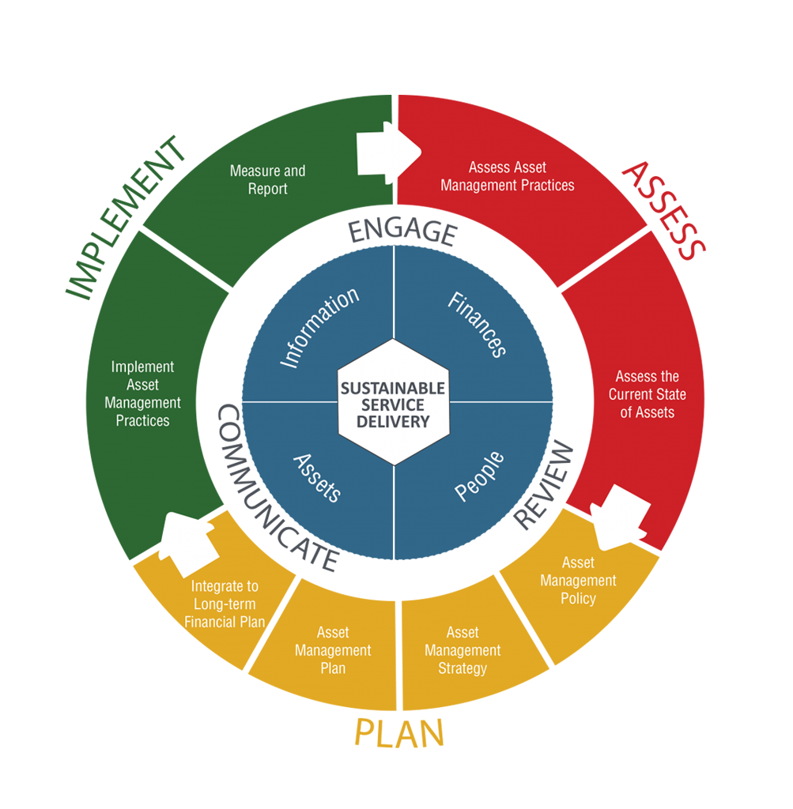
Figure 2: Asset Management BC Framework

Asset Management Policy
Discuss your Local Government’s efforts establishing and implementing asset management policy.

Council Direction – Asset Management
Discuss your Local Government’s governance steps and direction related to asset management.

Asset Management Program Component
[Use this section to demonstrate the variety of activities already underway by your organization to support asset management principles].
Table 1: Asset Management Program Components
Sanitary Master Plan |  | Parks Master Plan |  | Transportation Master Plan
Master Drainage Plan |  | Transportation Master Plan |  | Pavement Management Report
Vehicle Replacement Plan |  | Bridge Inspection Report |  | Appraisals
Strategic Plan |  | Financial Plan |  | Closed Captioned TV Inspections

SECTION B: OVERVIEW OF ASSET INVENTORY

Inventory Valuation

The estimated replacement costs of the Local Government’s Assets are approximately $XXXM. Approximately $227M of these assets are depreciable and will need to be replaced. The value of the Local Government’s Asset Inventory demonstrate the significant service-providing value they have to the Community.

Table 2: Asset Inventory Valuation
Asset | Quantity | Replacement Value | Useful Life
Natural Assets | Unknown | Unknown | Potentially Unlimited
Land | XX.X (ha) | $ XX,XXXX,XXX | Unlimited
Park Structures | N/A | X,XXX,XXX | 20-80 years
Vehicles | XX units | X,XXX,XXX | 13-17 years
Buildings | X,XXX m^2 | XX,XXX,XXX | 50-80 years
Road Infrastructure | XX.X km | XXX,XXX,XXX | 25-100 years
Drainage | XX.X km | XX,XXX,XXX | 50-100years
Sanitary Sewer | XX.X km | XX,XXX,XXX | 50-100years
Water Infrastructure | XX.X km | XX,XXX,XXX | 50-100years
Total |  | $ XXX,XXX,XXX
Total Depreciable Assets |  | $ XXXX,XXX,XXX

Inventory Consumption

Overall, the Local Government is estimated to have consumed 59.5% ($135.4M) of the value of its infrastructure. This suggests that Local Government infrastructure is halfway through its estimated useful life by value.

Table 3: Asset Inventory Consumption
Asset | % Consumed | $ Consumed | % Overdue | $ Value Overdue
Natural Assets | n/a | n/a | n/a | n/a
Land | n/a | n/a | n/a | n/a
Park Structures | XX.X% | $XXX,XXX | X.XX % | $XX.XM
Vehicles & Equipment | XX.X % | X,XXX,XXX | X.XX % | $XX.XM
Buildings | XX.X % | X,XXX,XXX | X.XX % | $XX.XM
Road Infrastructure | XX.X % | XX,XXX,XXX | X.XX% | $XX.XM
Drainage | XX.X % | XX,XXX,XXX | X.XX % | $XX.XM
Sanitary Sewer | XX.X % | XX,XXX,XXX | X.XX % | $XX.XM
Water Infrastructure | XX.X % | XX,XXX,XXX | X.XX % | $XX.XM
Total | XX.X% | $XXX,XXX,XXX

Consumption by major asset is displayed in figure 3. Road assets are estimated to be approximately XX% through their useful life with an estimated $XXM in road segments overdue for replacement. Road, Drainage, and Sanitary Sewer infrastructure replacement will represent a significant financial challenge to the Local Government for the coming decades between 2040 and 2070.

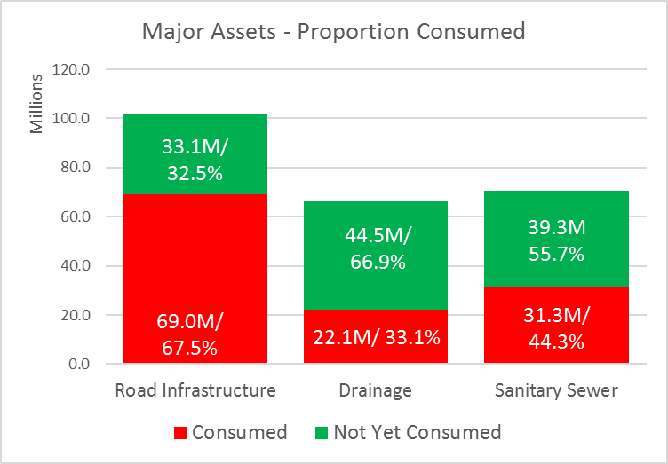
Summary of Asset Condition Assessments
Overall, condition assessments indicate that the Local Government’s assets are servicing the purpose for which they were constructed. The lagging indicator is funding which is currently inadequate in all categories except Park Structures. The Local Government’s infrastructure appears to be meeting the capacity needs of residents, and condition of the infrastructure is good given that most assets are not yet 50% consumed (see Table 3).

Table 4: Summary of Condition Assessments
Asset | Overall | Condition and Performance | Capacity Vs. Need | Funding Vs. Need
Park Structures | B+ | B | B+ | A
Vehicles | C | B | A- | F
Buildings | C | B | B+ | D-
Road Infrastructure | C+ | B | A- | F
Drainage | C | B | A- | F
Sanitary Sewer | B | B- | A- | F
Water Infrastructure

SECTION C: INFRASTRUCTURE FUNDING

Annual Funding Levels

Current annual funding levels are estimated to be $X,XXX,XXX. This assumes that the Local Government will use XX% Gas Tax and XX% of Casino revenues for infrastructure replacement.

Table 5: Current Infrastructure Funding
Funding Source | $ Value
Annual Transfers to Reserves: Taxation | $XXX,XXX
Annual Transfers to Reserves: Utility Fees | XX,XXX
Annual Transfers to Reserves Casino Revenue¹ | XXX,XXX
Annual Transfer to Reserve: Gas Tax | XXX,XXX
Debt Principal Payments | XXX,XXX
Annual Reserve Interest Revenue | XX,XXX
Total | $X,XXX,XXX
1: Actual Casino Revenue 10-year average 2012-2021 was approximately $XX.XM and actual 2022 budget was $X.XM. Using a weighted-average Council dedicated XX% of casino revenues toward capital in the 2022-2026 Financial Plan.

Summary of Reserves (Accumulated Funding)

[Should only list reserves that are for capital replacement (not new capital)]
Table 6: Current Reserve Balances
Reserve | $ 2022 Ending | Description
Casino Revenue | X,XXX,XXX¹
Community Works Fund | X,XXX,XXX
Capital Renewal | XXX,XXX
Fire Department Equipment | XXX,XXX
Machinery and Equipment | XXX,XXX
Park Improvements | XXX,XXX
Sewer System Capital | X,XXX,XXX
Total | $X,XXX,XXX
1: Actual Casino Revenue 10-year average 2012-2021 was approximately $XX.XM and actual 2022 budget was $X.XM. Using a weighted-average Council dedicated XX% of casino revenues toward capital in the 2022-2026 Financial Plan.

Sustainable Annual Funding vs Actual
Sustainable annual funding levels are estimated to be $X,XXX,XXX. This value is determined by the individual asset replacement costs divided by their estimated useful lives.

Table 7: Annual Funding Gap
Asset | Sustainable Annual Funding | Actual Annual Funding | Difference (Annual Funding Gap)
Natural Assets | n/a | n/a | n/a
Land | n/a | n/a | n/a
Park Structures | $ XX,XXX | 89,800 | $(XX,XXX)
Vehicles & Equipment | XXX,XXX | 194,800 | XXX,XXX
Buildings | XXX,XXX | XXX,XXX | XXX,XXX
Road Infrastructure | X,XXX,XXX | XXX,XXX | X,XXX,XXX
Drainage | XXX,XXX | XXX,XXX | XXX,XXX
Sanitary Sewer | XXX,XXX | XXX,XXX | XXX,XXX
Water Infrastructure
Total | $X,XXX,XXX | X,XXX,XXX | X,XXX,XXX

Accumulated Infrastructure Funding Gap
The Local Government’s Accumulated Infrastructure Funding Gap is estimated to be $XXXM. Since Assets are estimated to be XX.X% consumed, the sustainable reserve value would the replacement value of depreciable assets ($XXX.XM) x consumption (XX.X%) less actual reserves.
Table 8: Cumulative Infrastructure Funding Gap
Asset | Sustainable Reserve Target | Actual Reserve Balances¹ | Accumulated Infra. Funding Gap
Natural Assets | n/a | n/a | n/a
Land | n/a | n/a | n/a
Park Structures | $XXX,XXX | $XX,XXX | $ XXX,XXX
Vehicles & Equipment | X,XXX,XXX | XXX,XXX | X,XXX,XXX
Buildings | X,XXX,XXX | XXX,XXX | X,XXX,XXX
Road Infrastructure | XX,XXX,XXX | X,XXX,XXX | XX,XXX,XXX
Drainage | XX,XXX,XXX | X,XXX,XXX | XX,XXX,XXX
Sanitary Sewer | XX,XXX,XXX | X,XXX,XXX | XX,XXX,XXX
Water Infrastructure
Total | $XXX,XXX,XXX | $X,XXX,XXX | $XXX,XXX,XXX

1: Currently, Local Government Reserves are not dedicated by asset class as outlined above. Reserve balances are per figure x above. Reserve balances have been apportioned for illustration purposes only and have been allocated based $ value of replacement cost

SECTION D: MODELLING

Infrastructure Replacement Forecast 2023-2122

The Local Government is forecasted to spend approximately $XXXM (2022 dollars) over the next 100-years (2023-2122) on infrastructure replacement. This figure is dependent on selected capital services levels and does not include new infrastructure acquired through that period.
Approximately XX% ($XXXM) of that spending is expected to occur between 2053 – 2097 (45 years). The Local Government will need to prepare for this coming financial burden. It is estimated that $XX.XM (XX.X%) of the Local Government’s depreciable assets are overdue for replacement, highlighted in red below. 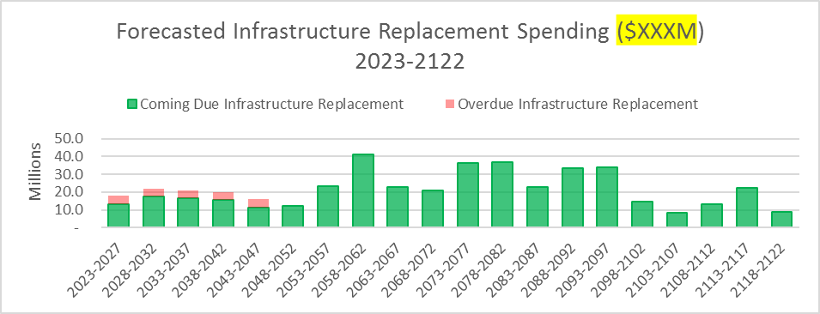
Figure 4: Forecasted Infrastructure Replacement Spending 2023-2122

Reserves & Debt Forecast 2023-2122

The annual sustainable funding required to replace the Local Government’s infrastructure is $X.XM. Current funding is approximately $X.XM, leaving an annual funding gap of approximately $X.XM. Left unchanged, this may lead to a 100-year funding gap totaling, approximately, $XXX.XM. 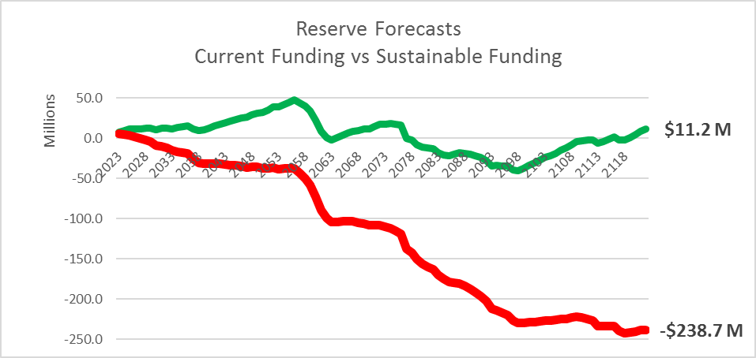
100-Year Funding Gap: $249.9M
Figure 5: Reserve Forecast - Current Funding vs Sustainable Funding
There are several options available to the Local Government’s to address this funding gap:
- Increase funding in the short-term: this option would allow costs to be spread out as fairly as possible over the generations of taxpayers who use the capital services.
- Defer funding increases: this option concentrates the costs of the capital services on fewer generations and creates intergenerational funding inequity. Furthermore, this option increases the lifecycle costs of the infrastructure as debt financing becomes necessary, increasing interest costs.
- Abandon Capital Services or Reduce Capital Service Levels: the Local Government does not have many options to reduce or abandon capital services as most are essential. However, the Local Government can choose to accept a higher-level of risk or reduced quality of capital service.

SECTION E: RECOMMENDATIONS

Funding Recommendations

Funding Recommendation One - Achieve Sustainable Funding Levels
The Local Government’s accumulated Infrastructure Funding Gap is estimated to be approximately $XXXM (see Table 8). The Local Government’s assets are approximately XX% through their useful life. The value of this consumption is estimated to be approximately $XXXM but only $X.XM has been set aside due to unsustainable annual funding levels.
The first step to halting growth in the Accumulated Infrastructure Funding Gap is to achieve Sustainable Annual Funding Levels. Current annual funding is approximately $X.XM while sustainable annual funding is estimated to be $X.XM. This means that the Local Government will need to increase annual funding by $X.XM to halt the Accumulated Infrastructure Funding Gap growth.
To achieve sustainable annual funding, the following measures are recommended:
Recommendation 1a – Immediately dedicate $XXX,XXX of the Local Government’s annual casino revenues toward infrastructure replacement.
Recommendation 1b – Implement X-years of X% Sewer User Fee increases (approximately $XX per average property per year).
Recommendation 1c – Implement XX-years of X% tax increases (approximately $XX per average residential property per year).
Recommendation 1d – Convert all debt servicing costs into annual infrastructure funding when debt expires.
If the Local Governments adopts these recommendations then it should be possible for annual sustainable funding to be achieved by 20XX.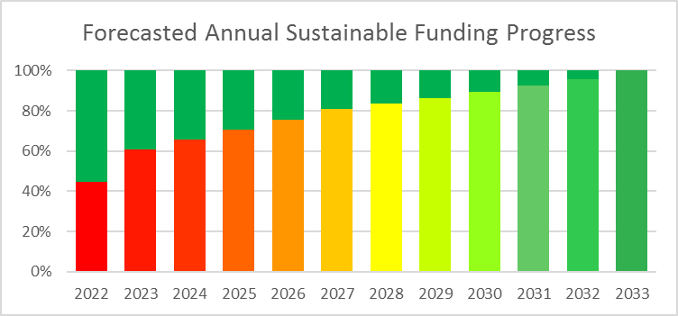
Figure 6: Forecasted Annual Sustainable Funding Progress

Table 9: Forecasted Annual Sustainable Funding Progress
2022 | 2023 | 2024 | 2025 | 2026 | 2027 | 2028 | 2029 | 2030 | 2031 | 2032 | 2033
45% | 61% | 65% | 70% | 76% | 81% | 84% | 86% | 89% | 92% | 96% | 100%

Funding Recommendation Two - Establish Dedicated Funding Streams for Major Asset Classes
Establishing dedicated reserve transfers and/or reserve funds for individual asset classes will allow the Local Government to manage risk and take part in capital service level decisions. For instance, Council can establish sustainable funding sources for asset classes that are in replacement sooner than other asset classes.

Policy Recommendations

An Asset Management (AM) Policy is an important tool to support the Local Government’s vision for sustainable service delivery. While the Local Government has not developed a comprehensive AM Policy, asset management practices can still be integrated into various other policies and operations.

Life-cycle Costing Policy Recommendations
Council should be provided with full life-cycle information when making decisions related to Local Government infrastructure.
Policy Recommendation One – Integrate Lifecycle Costing into Procurement Decisions
Procurement decisions utilize evaluation scoring based on numerous factors. Often financial considerations contribute between 30% and 60% to scoring. However, if a procurement decision only considers implementation or capital costs and fails to consider lifecycle costs, a more expensive salutation may be selected. For instance, the hypothetical software purchase example shown below:
Table 10: Acquisition Costing Method for Procurement
 | Software #1 | Software #2
Software Purchase | $50,000 | $100,000
Implementation Costs | $20,000 | $50,000
Total Acquisition Costs | $70,000 | $150,000

At first glance, Software #2 appears to be more expensive and, therefore, would receive half the score of Software #1. However, when evaluated from a lifecycle costing perspective, Software #2 is much less expensive:
Table 11: Lifecycle Costing Method for Procurement
 |  | Software #1 | Software #2
 | Software Purchase | $50,000 | $100,000
 | Implementation Costs | $20,000 | $50,000
A | Total Acquisition Costs | $70,000 | $150,000
B | Annual Licensing Costs | $20,000 | $10,000
C | Expected Useful Life | 10 years | 15 years
D | Total Licensing Cost per Useful Life (BxC) | $200,000 | $150,000
E | Total Lifecycle Costs (A+D) | $270,000 | $300,000
F | Annualized Lifecycle Costs (E/C) | $27,000 per year | $20,000 per year

Notice that under the Acquisition Costing Procurement Method in table 11, Software #2 appears to be more than twice as expensive. However, Software #2 is found to be 25% less expensive when annual lifecycle costs are calculated.
It is therefore recommended that the Local Government’s Purchasing Policy XXX be amended to encourage staff to consider lifecycle costs when scoring procurement processes.
Policy Recommendation Two – Integrate Lifecycle Costing into Budget Deliberations
Table 12: Operating vs Capital Budget
2022 Budget | Amount | Proportion
Operating Expenses | $16,221,674 | 79.4%
Capital Expenses& Debt Principal | 4,203,755 | 20.6%
Total | $20,425,429 | 100.0%
At first glance, the Local Government’s budget seems concerned with only a small proportion of capital. However, the Local Government’s 2022 Financial Plan includes provisions for $XX.XM in operating expenses and $X.XM in Capital Expenditures and Debt Principles.
Considering what drives operating expenses in the budget, it is clear that most costs arise from capital services. Most operating costs are incurred to operate or maintain capital.
Table 13: Budget Devoted to Providing Capital Services
Expense | Amount
Operating expenses devoted to operating or maintaining capital | $9.9M
Capital & principal payments | 4.2M
Total budget to provide capital services | 14.1M
Total 2022 budgeted expenses | 20.4M
Proportion of total budget | 69.1%

When capital expenditure decisions are made during budget deliberations, it is imperative that Council consider the full lifecycle costs of the capital. This would include the initial capital outlay (construction and acquisition costs), lifetime operating, and maintenance costs. Council should also consider what capital service level vision they have for the infrastructure. For instance, when a road is under construction, Council should decide what Pavement Condition Index (PCI) score staff are expected to maintain.
Policy Recommendation Three – Integrate Lifecycle Costing Land-Use Decisions
As the Local Government grows and develops, new infrastructure is constructed to provide critical services to citizens. A municipality’s Zoning and Subdivision/Development Servicing Bylaws strongly influence the amount of infrastructure constructed when development occurs. The Zoning Bylaw regulates density and use while the Subdivision/Development Servicing Bylaw regulates off-site services.
Asset Management BC recommends that an assessment of lifecycle costs be conducted when land-use decisions are proposed. This is important for several reasons:
- A municipality’s tax rate may be unsustainable, and new development will compound financial pressures. New properties will be subject to established tax rates. The Local Government’s current tax rates are not sustainable as they do not fund the full lifecycle costs of Local Government infrastructure. New development will, therefore, compound growth in the Cumulative Infrastructure Funding Gap.
- Most of an asset’s costs are incurred as operating and maintenance costs through its lifecycle. Initial construction costs are paid for by developers and given to the municipality as donated capital. However, the municipality will incur operating, maintenance, and replacement costs going forward.
- New taxes from new development initially exceed costs, but this is deceiving. Often the municipality will benefit from increased tax revenues when a property is initially subdivided. Even more revenue is earned when a property is developed and new buildings added. However, the capital maintenance, operating maintenance, and replacement costs all lag. Therefore, when a municipality uses new development taxation revenue to reduce the tax burden for current taxpayers, the true cost of development is not integrated into the tax rate.
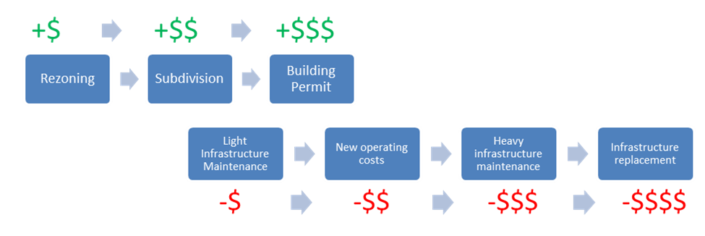
Figure 7: Lifecycle Costs of New Development

The following policies are recommended in respect of land use and asset management:
- Policy Recommendation 3a: Require lifecycle costing analysis to be conducted when rezoning applications are prepared
- Policy Recommendation 3b: Utilize Non-Market Change revenue to increase transfers to reserves for capital replacements

Investment Recommendations
Investment Recommendation One – Align long-term cash flows with long-term investment portfolio horizon
Aligning the Local Government’s investment portfolio with long-term cash flow projections will allow the Local Government to generate the highest investment return. Investment returns can significantly reduce the Local Government’s need to raise taxes and utility fees in order to fund infrastructure replacement.

CHART SHOWING IMPACT OF INVESTMENT REVENUES
Figure 8: [Placeholder: Investment Return Modelling]

SECTION F: DETAILED INVENTORY OF INFRASTRUCTURE

Nature Assets
There is currently no universally accepted definition of a Natural Asset. However, Asset Management BC recommends the following definition:

“Municipal natural assets refer to the stock of natural resources or ecosystems that is relied upon, managed, or could be managed by a municipality, regional district, or other form of local government for the sustainable provision of one or more municipal services.”

The Local Government prepares its Financial Statements according to the accounting standards set out in the Public Sector Accounting (PSA) Handbook. These standards outline financial disclosures and accounting related to Tangible Capital Assets. Tangible Capital Assets must either be constructed or purchased to be recorded in the Local Government’s financial statements. Unfortunately, this precludes the accounting for many natural assets.

Natural Assets should occupy an important place in a municipality’s long-term financial planning process. Not only do these assets provide a valuable service to the community, one that citizens enjoy and depend on, but they often offset the cost of constructing and maintaining grey infrastructure. For example, creeks and rivers provide valuable drainage services, while foreshore and trees provide recreational value.

Since Natural Assets are neither acquired or constructed, there is no consistent way to value such assets. An organization may choose to value its Natural Assets in a multitude of ways:

Table 14: Natural Asset Valuation Methods
Natural Asset | Potential Valuation Model
Trees (Urban Forest) | - Value of reduced healthcare costs that result from cleaner air.  - Value of carbon offsets that do not need to be purchased.  - Cost to purchase, plant, maintain, and water a tree until maturity.
Creeks, Rivers | - Cost of comparable recreational value provided by built infrastructure.  - Lifecycle of grey infrastructure that doesn’t have to be built due to drainage services provided by creeks and rivers.
Foreshore | - Cost of comparable recreational value provided by built infrastructure.

Land and Park Inventory
The Local Government owns approximately XX hectares of land, valued at over $XXM. In addition, there are other parks within the Local Government’s borders that are owned and maintained by other levels of government. These have not been included in the inventory below.

Table 15: Land Value Summary
Land Classification | Area (Hectares) | Assessed Value ($millions)
Land under Buildings | X.XX | $X.X
Parkland | XX.XX | XX.X
Total | XX.XX | $XX.X
Table 16: Parkland Listing
Park Land | Park Classification¹ | Area (ha) | Assessed Value ($millions)
XXXX Park | Natural Greenspace | 0.76 | $ 1.02
XXXX | Natural Greenspace | 1.31 | 1.05
XXXX | Neighbourhood Park | 2.59 | 5.46
XXXX Phase 7 | Natural Greenspace | 1.92 | 2.70
XXXX Creek | Natural Greenspace | 1.57 | 1.47
XXXX | Natural Greenspace | 5.38 | 3.02
XXXX Meadows | Neighbourhood Greenspace | 0.72 | 0.98
XXXX | Community Park | 2.58 | 1.91
XXXX Grove | Natural Greenspace | 0.96 | 0.92
XXXX Hill | Natural Greenspace | 1.85 | 2.52
N XXXX Hill | Community Park | 4.32 | 2.04
XXXX | Community Park | 6.38 | 5.92
XXXX | Shoreline Access | 0.73 | 0.90
XXXX Hill | Natural Greenspace | 2.60 | 2.00
XXXX | Shoreline Access | 0.13 | 0.50
XXXX | Community Park | 6.33 | 2.04
Other | Neighbourhood Park | 0.54 | 2.31
Other | Natural Greenspace | 0.83 | 1.92
Other | Shoreline Access | 0.88 | 2.25
Other | Neighbourhood Greenspace | 6.90 | 9.62
Other | Linear Park | 0.36 | 0.82
Other | Special Purpose | 0.28 | 1.03
Total |  | 49.93 | $52.4
1: See Glossary for definition

Table 17: Land Under Building Listing & other Land
Land Under Building | Area (ha) | Assessed Value ($millions)
Town Hall | 0.XX | $X.X
Fire Hall | 0.XX | X.X
Recreation | n/a | X.X¹
Library | n/a | X.X¹
Police Station | n/a | X.X¹
Total | X.XX | $X.X
1: Based on proportionate share of property; see Scope of Work and Limitations section

Rivers, Creeks, Streams
Approximately 18km of creeks and streams run through the Local Government’s borders. These streams provide drainage services and help to cultivate the natural ecosystems within. The lifecycle costs that the Local Government’s avoids by properly caring for these creeks and streams is estimated to exceed $XXX,000 annually.
Table 18: Lifecycle Costing Valuation of Rivers, Creeks, and Streams
Creek | Length (Km) | Capital Cost of Grey Infrastructure Alterative¹ | Annual Operating Cost of Grey Infrastructure Alternative² | Annual Life-Cycle Costs of Grey Infrastructure Alternative³
XXX Creek | 7.0 | $X,X00,000 | $XX,000 | $XXX,X00
XXX Creek | 0.4 | XXX,000 | X,X00 | X,X00
XXX Creek | 1.3 | X,XXX,000 | X,X00 | XX,XX0
XXX Stream | 1.5 | X,X00,000 | X,X00 | XX,XX0
XXX Creek | 0.4 | XX0,000 | X,X00 | X,X00
XXX Creek | 1.5 | X,X00,000 | XX,X00 | XX,XX0
Other | 6.1 | X,XX0,000 | XX,X00 | XXX,XXX
Total | 18.2 | $XX,XX0,000 | $XXX,X00 | $XXX,X00
1: Estimated cost per meter $1.4M
2: Estimated cost per meter $7,000
3: Assumed 80-year useful life for Grey Infrastructure alternative

Trees
The Local Government maintains approximately X,X00 trees on its boulevards.
Table 19: Trees Inventory
Tree Species | Count
Red Maple | 304
Dogwood | 95
Garry Oak | 52
Magnolia | 48
Douglas Fir | 47
Big Leaf Maple | 46
Ornamental Plum | 44
Spruce | 36
Norway Maple | 35
Katsura | 32
Liquidambar | 31
Pin Oak | 31
Western Red Cedar | 27
Ornamental Cherry | 24
Fir | 22
Pine | 20
Unknown | 67
Other | 261
Total | 1,222

Foreshore

The Local Government has approximately X.Xkm of foreshore, much of which is publicly accessible. The public enjoys a significant recreational benefit from frequent use of the waterfront.

Park Structures

Park Structures Inventory
Table 20: Park Structure Inventory Overview
Structure | Service Life | Quantity | Current Replacement Cost | Annualized Cost | % Consumed
Benches | 25 years | 76 each | $114,000 | $ 5,000 | Unknown
Parking Lots | 25-80 years | 8000 m^2+ | 1,800,000 | 23,000 | 28%
Play Structures | 25 years | 20 each | 788,500 | 31,500 | 27%
Tables | 20 years | 18 each | 36,000 | 2,000 | Unknown
Total |  |  | $2,738,500 | $61,500 | 28%

Park Structures Condition Assessment

Table 21: Park Structure Condition Assessment
Asset | Overall | Condition and Performance | Capacity Vs. Need | Funding Vs. Need
Benches | A- | B | A- | A-
Parking Lots | B- | B | B- | B-
Play Structures | B+ | B | B+ | A
Sports Courts | B- | B | B- | B-

Park Structures Spending Forecast

Forecasted Spending, Park Structures 2023-2122 | $XX.XM
Sustainable Annual Funding | $XX,X00

Spending on park structure replacement and capital maintenance for the next 100 years is expected to be $XX.XM (2022 dollars). The estimated annual sustainable infrastructure reserve contribution for park structures is approximately $XX,X00. Annual funding is currently at sustainable levels. 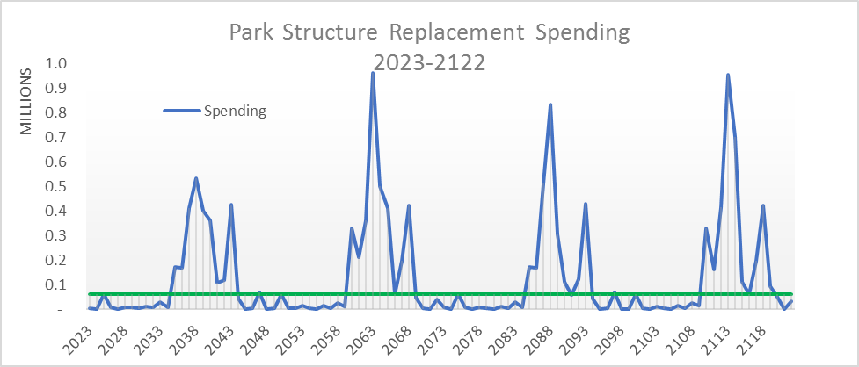
Figure 9: Park Structure Replacement Spending 2023-2122

Vehicles
The Local Government maintains a vehicle inventory of approximately XX units which service the Parks Department, General Administrative staff, and Protective Services division. The replacement value of the fleet is estimated to exceed $X.XM. The vehicles are approximately XX% through their lifecycle on average.

Vehicles Inventory

Table 22: Vehicle Inventory Overview
Structure | Service Life | Quantity | Current Replacement Cost | Annualized Cost | % Consumed
General Administrative | 14 to 17 years | XX | $XXX,000 | $XX,X00 | XX%
Fire Department | 15 years | XX | X,XXX,000 | XXX,000 | XX%
Total |  | XX | $X,XXX,000 | $XXX,X00 | XX%

Vehicles Condition Assessment
Table 23: Vehicle Condition Assessment
Asset | Overall | Condition and Performance | Capacity vs. Need | Funding vs. Need
General Administrative | B+ | B | B | A
Fire Department | C- | B | A | F

Vehicles Spending Forecast
Table 24: Vehicle Funding Snapshot
Forecasted Spending, Vehicle Replacement 2023-2122 | $XX.XM
Sustainable Annual Funding | $XXX,000
Current Annual Funding | $XX,X00
Annual Funding Gap | $XXX,X00
100-year Funding Gap | $XX.XM

The Local Government is currently setting aside insufficient funding for the replacement of its vehicles. This results in the Local Government having to fund via debt or by using an undedicated funding source. For example, the Local Government is utilizing 2023 casino revenues to replace a major piece of fire apparatus. This unsustainable funding model will result in a 100-year funding gap of $XX.XM as represented by the red shaded area between the sustainable and current funding lines in Figure 10 below.

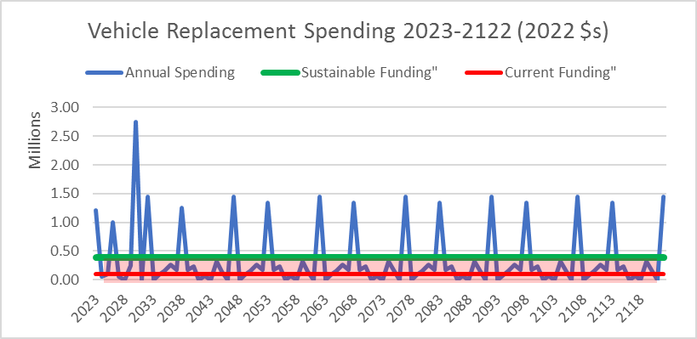
Figure 10: Vehicle Replacement Spending 2023-2122

Buildings
The Local Government maintains a small portfolio of Buildings to house its Municipal Operations. The list below includes buildings not exclusively owned by the Local Government, such as the XXX Parks and Recreation facilities, the XXX RCMP building, and the XXX Public Library. The Local Government has a stake in each of these buildings directly or indirectly. The Plan assumes that the Local Government will want to continue to provide existing capital services. Therefore, buildings with an indirect stake and potential financial implications are included in the modelling and forecasts.

Buildings Inventory

Table 25: Building Inventory Overview
Structure | Service Life | Quantity | Current Replacement Cost | Annualized Cost | % Consumed
Municipal Hall | 80 years | XXX m^2 | $X,XXX,000 | $XX,X00 | XX%
Public Safety Building | 80 years | X,XXX m^2 | X,XXX,000 | XXX,X00 | XX%
Recreation | 80 years | XX,XX m^2 | XX,XXX,000¹ | XXX,X00 | XX%
Police Detachment | 80 years | X,XXX m^2 | X,XXX,000² | XX,X00 | XX%
Public Library | 80 years | X,XXX m^2 | X,XXX,000³ | XXX,000 | X%
Parks Building | 80 years | XXX m^2 | XXX,X00 | X,X00 | XX%
Park Washrooms & Concession | 80 years | XXX m^2 | XXX,000 | XX,X00 | X%
Total |  |  | $XX,XXX,X00 | $XXX,X00 | XX%
- Local Government Total replacement costs of all facilities exceed $XXM.
- Local Government’s proportionate share of the building assets at Police Detachment. Total replacement costs of all facilities are estimated to be over $X.XM.
- Local Governments’ proportionate share of the building assets at the Public Library Central Branch. Total replacement costs of all facilities is estimated to be over $XXM.

Buildings Condition Assessment
Table 26: Building Condition Assessment
Asset | Overall | Condition and Performance | Capacity vs. Need | Funding vs. Need
Municipal Hall | B- | B+ | A | D
Fire Hall | B | A | A | D
Recreation | C | B- | B- | F
Police Detachment | C | B- | B- | F
Public Library | C+ | B | B | F
Parks Building | C+ | B+ | A- | D

Buildings Spending Forecast

Table 27: Building Funding Snapshot
Forecasted Spending, Buildings 2023-2122 | $XX.XM
Sustainable Annual Funding | $XXX,X00
Current Annual Funding | $XXX,X00
Annual Funding Gap | $XXX,X00
100-year Funding Gap | $XX.X

Spending on building replacement and capital maintenance for the next 100-years is expected to be $XX.XM (2022 dollars). The estimated annual sustainable infrastructure reserve contribution for buildings is $X.XM, while the current funding is $X.XXM (undedicated). If this funding level continued, then the Local Government would face an additional $XX.XM in its cumulative funding gap by 2123.
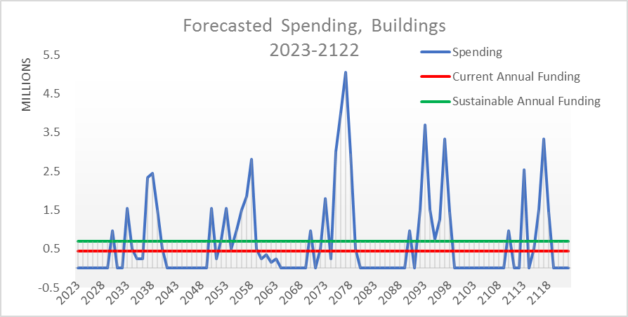
Figure 11: Forecasted Spending, Buildings 2023-2122

Road Infrastructure
The Local Government maintains a significant road network, including approximately 49km of asphalt and 26km of sidewalk. Much of the Local Government’s road network, including multiple bridges (approximately 20km) is utilized significantly by the region’s citizens.

Road Inventory
Table 28: Road Inventory Overview
Structure | Service Life  (Top/Base) | Quantity | Current Replacement Cost¹ | Annualized Cost | % Consumed
Local | 25/90 | 38.9 km/270,000m^2 | $XX,XXX,x00 | $XXX,X00 | XX%
Collector | 25/80 | 1.2 km/11,000m^2 | X,XXX,X00 | XX,X00 | XX%
Arterial | 25/80 | 7.8km/76,000 m^2 | XX,XXX,000 | XXX,000 | XX%
Other Road | 25/80 | 1.0km/2,000m^2 | X,XXX,X00 | XX,X00 | XX%
Total Roads |  | 48.9km/359,000m^2 | XX,XXX,X00 | $X,XXX,X00 | XX%
Bridges
Curb & Gutter | 80 years | 39.4km² | XX,XX0,000 | XXX,X00 | XX%
Sidewalk | 80 years | 25.5 km/41,900m^2 | XX,XXX,X00 | XXX,X00 | XX%⁴
Streetlights | 25 years | 526 each | N/A | N/A³ | N/A
Traffic Signals | 25 years | 35 each | X,X00,000 | XXX,X00 | XX%
Total |  |  | XXX,XXX,X00 | $X,XXX,X00 | XX%
1: Current replacement costs represent the value for a full reconstruction which includes top and base layers. However, over the lifespan of a road, the top coat may be reconstructed 2-4 times.
2: This is measured for each side of the road. For example, 1 km of road with curb and gutter on both sides would measure as 2 km of curb and gutter.
3: Replacement costs borne by BC Hydro.
4: Sidewalk installation dates are unknown; therefore a 50% consumption rate has been assumed

Road Condition Assessment
In 2019 XXX Management Services, LLC (XXX) was contracted by the Local Government to conduct a pavement condition assessment and analysis on approximately XXkm of Local Government maintained asphalt roadways. The Local Government’s roads were rated with a Pavement Condition Index (PCI) Score. The Local Government’s average score was found to be approximately 69, which is above the estimated national average of between 60 and 65. Approximately XX% of roads were found to be in very good or excellent condition. The report outlined spending options for the Local Government to maintain or improve its PCI score.
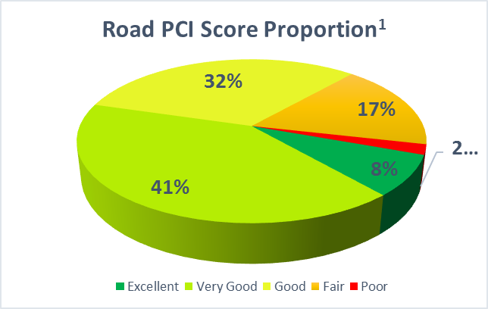
Figure 12: Road PCI Score Proportion
1: Source: Pavement Management Analysis Report. (2020, February). IMS Infrastructure Management Services

Table 29: Road Condition Assessment
Asset | Overall | Condition and Performance/PCI¹ | Capacity Vs. Need | Funding Vs. Need
Local | C+ | B/69 | A | F
Collector | C+ | B+/73 | B+ | F
Arterial | C+ | B/68 | B | F
Bridges | C+ | B²/N/A | B+ | F
Curb & Gutter | C+ | B/N/A | A | F
Sidewalk | C | B/N/A | B- | F
Other | C | B/N/A | B | F
1: Per Pavement Management Analysis Report. (2020, February). IMS Infrastructure Management
2: Per Bridge Inspection Reports 2020, Herold Engineering

Road Spending Forecast

Table 30: Road Funding Snapshot
Forecasted Spending, Road Replacement 2023-2122 | $XXX.XM
Sustainable Annual Funding | $X,XXX,X00
Current Annual Funding | $XXX,000
Annual Funding Gap | $X,XXX,X00
100-year Funding Gap | $XXX.0M

69% of the Local Government’s road network is well through its estimated useful life. This suggests that much of the network will be due for replacement soon. Given that the replacement cost of the road network is valued at approximately $XXXM, the Local Government can expect significant financial pressures in the midterm.
Modelling indicates that the Local Government may spend approximately $XXXM on roads over the next 100-years. Approximately $XXM of this amount is for a backlog of road segments that have reached or exceeded their estimated useful lives.

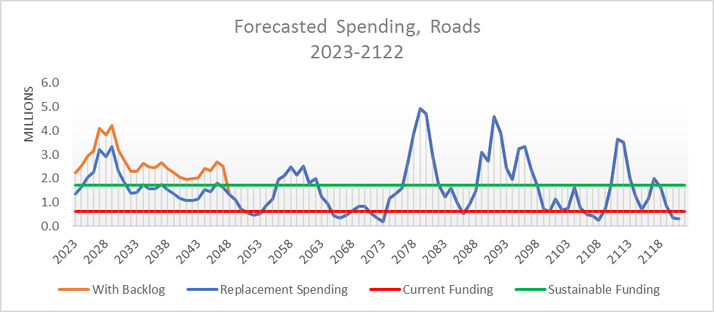

Figure 13: Forecasted Spending, Roads 2023-2122

Drainage
[Placeholder for your local government’s drainage infrastructure map]
The total catchment area for the urban portion of the Local Government is XXX hectares. The drainage system in this portion consists of a large number of storm drains, ditches, and culverts that discharge to four major receiving water bodies through XX outfalls. These bodies of water include Esquimalt Harbour, Portage Inlet, Craigflower Creek, and Millstream Creek.
Figure 14: Drainage Catchment Plan

Drainage Inventory

Table 31: Drainage Inventory Overview
Structure | Service Life | Quantity | Current Replacement Cost | Annualized Cost | % Consumed
Mains | 75-100 years | XX.0 km | $XX,XXX,000 | $XXX,X00 | XX%
Laterals | 80 years | X.X km | Included in Main Cost | Included in Main Cost | XX%
Catch Basin | 80 years | XXX ea. | Included in Main Cost | Included in Main Cost | XX%
Culvert | 80 years | XX.X km | XX,XXX,X00 | $XXX,000 | XX%
Total |  |  | XX,XXX,X00 | XXX,X00 | XX%

Drainage Condition Assessment

Table 32: Drainage Condition Assessment
Asset | Overall | Condition and Performance | Capacity Vs. Need | Funding Vs. Need
Mains | C | B | A- | F
Laterals | C | B | A- | F
Manholes | C | B | A- | F

Drainage Spending Forecast

Table 33: Drainage Funding Snapshot
Forecasted Spending, Drainage 2023-2122 | $XX.XM
Sustainable Annual Funding | $XXX,X00
Current Annual Funding | $XXX,X00
Annual Funding Gap | $XXX,X00
100-year Funding Gap | $XX.0M

Modelling indicates that the Local Government may spend approximately $XXM on Drainage infrastructure replacement over the next 100-years. 33% of the Local Government’s Drainage infrastructure is estimated to be through its estimated useful life.
The Local Government is expecting to be funding the replacement of this infrastructure at % of sustainable funding levels. The Local Government will have to significantly increase its funding levels to meet the upcoming financial obligations for infrastructure replacement.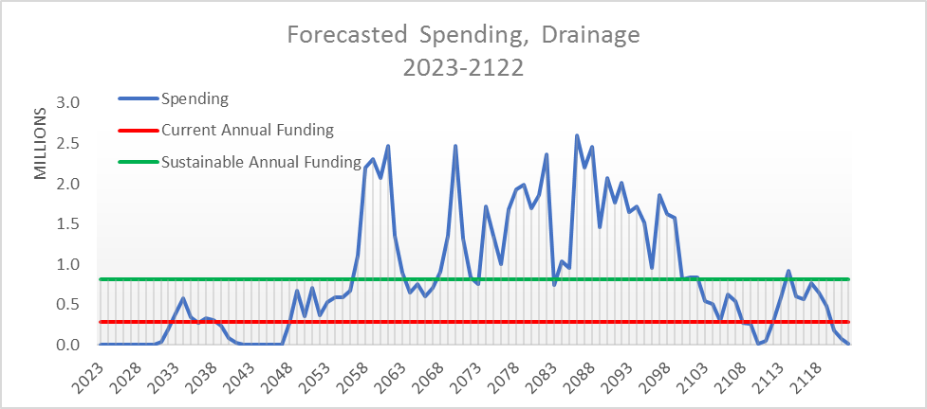
Figure 15: Forecasted Spending, Drainage 2023-2122

Sanitary Sewer Infrastructure
The Local Government’s sanitary sewer system is comprised of a gravity collection pipe network and XX pumping stations. This system discharges both directly and indirectly to the XXX pumping station. It then transfers, via the XXX trunk sewer, to XXX Point.
Figure 16: Sanitary Sewer System
[Placeholder for your local government’s sanitary sewer infrastructure map]

Sanitary Sewer Inventory

Table 34: Sanitary Sewer Inventory Overview
Structure | Service Life | Quantity | Current Replacement Cost | Annualized Cost | % Consumed
Gravity Mains | 50-100 years | XX.Xm | $XX,XXX,X00 | $XXX,X00 | XX%
Pressure Mains | 50-100 years | X.Xm | X,XXX,X00 | XX,000 | XX%
Laterals | 50-100 years | XX.Xm | Included in Main cost | Included in Main cost | XX%
Manholes | 50-100 years | XX ea. | Included in Main cost | Included in Main cost | XX%
Cleanouts | 50-100 years |  | Included in Main cost | Included in Main cost | XX%
Pump Stations | 50 years | XX ea. | X,XXX,000 | XXX,X00 | XX%
Total |  |  | $XX,XXX,X00 | $XXX,X00 | XX%

Sanitary Sewer Condition Assessment

Table 35: Sanitary Sewer Condition Assessment
Asset | Overall | Condition and Performance | Capacity Vs. Need | Funding Vs. Need
Gravity Mains | B | B- | A- | D
Pressure Mains | B | B- | A- | D
Laterals | B | B- | A- | D
Lift Stations | B | B- | A- | D
Manholes | B | B- | A- | D

Sanitary Sewer Spending Forecast

Table 36: Sanitary Sewer Funding Snapshot
Forecasted Spending, Sanitary Sewer 2023-2122 | $XX.XM
Sustainable Annual Funding | $XXX,X00
Current Annual Funding | $XXX,X00
Annual Funding Gap | $XXX,000
100-year Funding Gap | $XX.XM

Modelling indicates that the Local Government may spend approximately $XXM on Sanitary Sewer replacement over the next 100-years. The Local Government’s Sanitary Sewer infrastructure is estimated to be XX% through its estimated useful life. Over one-third of Sanitary Sewer infrastructure ($XXM) is expected to come due for replacement between 20XX and 20XX.
The Local Government is expecting to be funding the replacement of this infrastructure at XX% of sustainable funding levels. The Local Government will have to significantly increase its funding levels to meet the upcoming financial obligations for infrastructure replacement.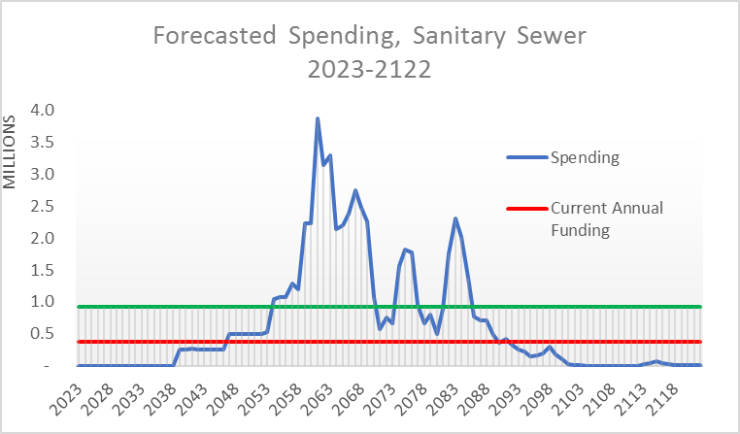
Figure 17: Forecasted Spending, Sanitary Sewer 2023-2122

Water Infrastructure
Local Government is supplied with potable water from XXX Reservoir via the XXX Water Supply System operated by the XXX). The Local Government system is bordered by the District of XXX to the north and the City of XXX to the west. The Local Government water distribution system is comprised of:
- X pump stations;
- X pressure reducing valve (PRV) stations;
- XXX km of water main;
- X,XXX service connections;
- X,XXX main line valves; and
- XXX hydrants.

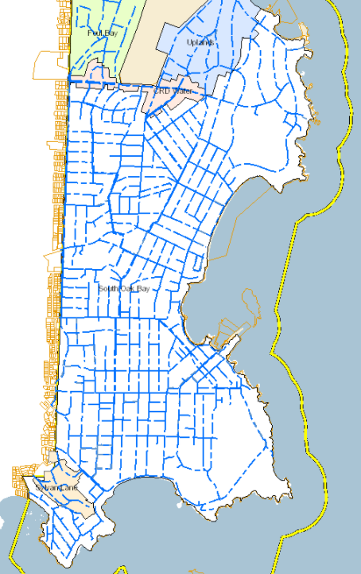
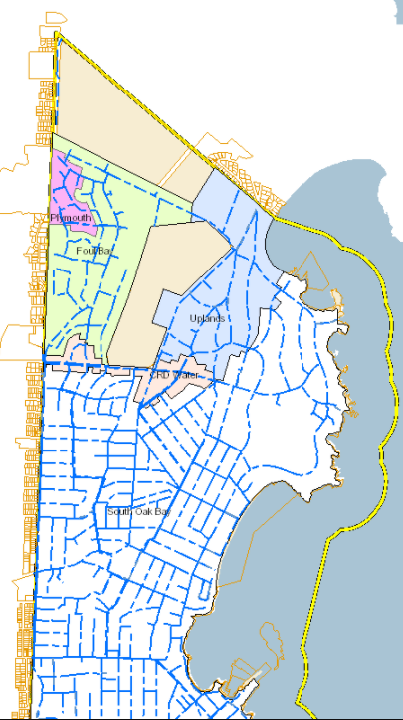

Water Infrastructure Inventory

Table 37: Water Infrastructure Inventory Overview
Structure | Service Life | Quantity | Current Replacement Cost | Annualized Cost | % Consumed
Mains | 50-100 years | XX.Xm | $XX,XXX,X00 | $XXX,X00 | XX%
Laterals | 50-100 years | XX.Xm | Included in Main cost | Included in Main cost | XX%
Hydrants |  | XX ea. | $X.XM | $X.XM | XX%
Valves |  | XX ea. | Included in Main cost | Included in Main cost | XX%
Meters |  | XX ea. | $X.XM | X.XM
Life Stations |  | XX ea.. | $X.XM | X.XM | XX%
Total |  |  | $XX,XXX,X00 | $XXX,X00 | XX%

Water Infrastructure Condition Assessment

Table 38: Water Infrastructure Condition Assessment
Asset | Overall | Condition and Performance | Capacity Vs. Need | Funding Vs. Need
Mains | B | B- | A- | D
Laterals | B | B- | A- | D
Hydrants
Valves | B | B- | A- | D
Life Stations
Lift Stations | B | B- | A- | D

Water Infrastructure Spending Forecast

Table 39: Water Infrastructure Funding Snapshot
Forecasted Spending, Sanitary Sewer 2023-2122 | $XX.XM
Sustainable Annual Funding | $XXX,X00
Current Annual Funding | $XXX,X00
Annual Funding Gap | $XXX,000
100-year Funding Gap | $XX.XM

Modelling indicates that the Local Government may spend approximately $XXM on Water Infrastructure replacement over the next 100-years. The Local Government’s infrastructure is estimated to be XX% through its estimated useful life. Over one-third of Sanitary Sewer infrastructure ($XXM) is expected to come due for replacement between 20XX and 20XX.
The Local Government is expecting to be funding the replacement of this infrastructure at XX% of sustainable funding levels. The Local Government will have to significantly increase its funding levels to meet the upcoming financial obligations for infrastructure replacement.

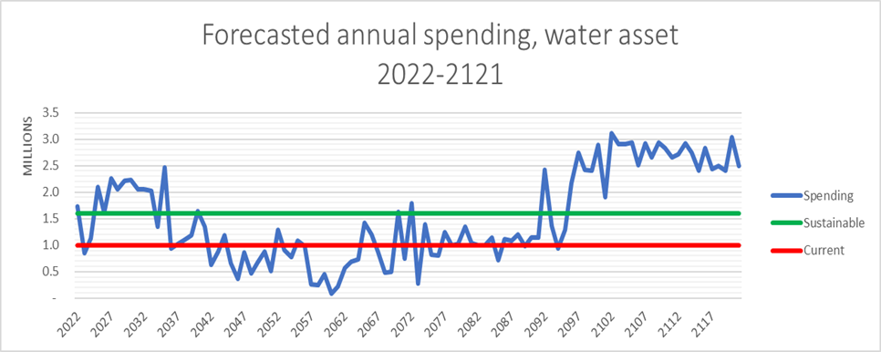
Figure 18: Forecasted Spending, Water Infrastructure 2023-2122

GLOSSARY OF TERMS

Annual Lifecycle Costs: Annual lifecycle costs include the cost to acquire or construct a Tangible Capital Asset, plus all operating and maintenance costs incurred over the life of the asset.
Community Park: Generally large parks provide passive and active recreation options, with a range of amenities of interest to the entire community. These spaces may also contain significant environmental features.
Forced Growth: Relates to costs that the Local Government must incur to continue to provide existing services at the same service level. For instance, collective agreement increases, inflation, and contractual increases are forced growth factors. Forced growth is not increases to service delivery costs resulting from elective changes or enhancements to existing programs. In the context of capital budgeting, forced growth refers to the inflationary pressure resulting in increased construction costs.
Grey Infrastructure: Built infrastructure that relates to stormwater, drainage, or flood mitigation.
Municipal Finance Authority: The Municipal Finance Authority of British Columbia (MFA) was created in 1970 to contribute to the financial well-being of local governments throughout BC. The MFA pools the borrowing and investment needs of BC communities through a collective structure and can provide a range of low-cost and flexible financial services to clients equally, regardless of the size of the community. The MFA is independent of the province and operates under the governance of a Board of Members appointed from the various Regional Districts within BC.
Neighbourhood Park: These are generally smaller in area than community parks and respond to the open space and recreation needs of residents. Amenities include passive and active recreation uses, along with significant open space.
Non-Market Change Revenue: Taxation revenue that results from taxable land or buildings that were not subject to taxes in the previous year. For example, newly built taxable buildings, previously exempt taxable property, newly subdivided land, or valuation increase due to zoning amendments.
Pavement Condition Index (PCI): This is an index that assigns a score between 0 and 100, indicating the general condition of pavement.
Request for Proposal (RFP): A formal procurement document that outlines an organization’s intent to purchase a good or service. The buyer issues the RFP to provide background information to potential vendors and invites them to submit a proposal to meet the requirements.
Tangible Capital Asset (TCA): Tangible capital assets are non-financial assets having physical substance that:
- are held for use in the production or supply of goods and services, for rental to others, for administrative purposes or for the development, construction, maintenance, or repair of other tangible capital assets,
- have useful economic lives extending beyond an accounting period,
- are to be used on a continuing basis, and
- are not for sale in the ordinary course of operations.

APPENDIX A: BASIS FOR CONDITION ASSESSMENT

Since it is unrealistic to scientifically rate every asset for a high-level Infrastructure Condition Report, a modified American Society of Civil Engineers (ASCE) alphanumeric system was employed for each asset component grouping. Assets are evaluated on a simplified component-by-component basis. Although every rating system is subjective, this process improves accuracy since it incorporates the anecdotal knowledge of the employees with respect to the assets.
The assets (by individual components) are rated using a two-step process in order to ensure consistency, focus, and detail:
Step 1: The first step was to rate the current condition to start understanding the makeup of the overall rating and identify the potential problems the managers were facing. This detailed rating takes into consideration three factors:
- Condition and Performance,
- Capacity vs. Need, and
- Funding vs. Need.
Condition and Performance: This first criterion characterizes the current physical condition of infrastructure. The condition index scale below is a general guideline for grading under this category:
A | Excellent: No noticeable defects. Some aging or wear may be visible
B | Good: Only minor deterioration or defects are evident. Still functions.
C | Fair: Deterioration or defects evident, but function not significantly affected.
D | Poor: Serious deterioration in at least some portion of the structure. Function is inadequate.
F | Failed: No longer functional. A general failure or complete failure of a major structural component.

Capacity vs. Need: For most infrastructure categories, this second criterion relates to the demand on a system, such as volume or use, versus its design capacity. This is a critical evaluation criterion for municipalities that are facing ongoing population and community growth. It is also important because a particular asset may be in excellent condition and performing well, but it is simply too small to meet the needs. A grading scale in 10-percent increments is suggested as a guideline for purposes of intuitive assessment as follows:
A | Systems that can support 100% of demand
B | Systems that can support 90 - 99% of demand
C | Systems that can support 80 - 89% of demand
D | Systems that can support 70 - 79% of demand
F | Systems that can support less than 70% of demand

Funding vs. Need: The third evaluation criterion reflects the status of funding dedicated to maintaining, replacing, and improving the current condition of existing infrastructure.
Infrastructure systems require funding that is dedicated, indexed, long-term, and, most importantly, sustainable. The primary measure is the amount of funding provided versus the estimated funds needed to meet or maintain the community’s desired quality or performance standard.
Dedicated funds, such as user fees and development charges, need to be applied only to infrastructure systems for which they are raised. Indexing means that funds need to increase as use of the system increases, or as the cost of providing the service increases.
Maintenance and construction costs also need to be considered in the evaluation of funding. Steady funding provides for maintenance that extends the life of infrastructure. Long-term, multi-year funding plans should account for growth estimates so that projects can be designed and constructed in anticipation of needs where it is logical and feasible to do so, and not simply in reaction to inadequate capacity or problems caused by poor maintenance.
This grading system is used as a guideline for purposes of intuitive assessment:
A | 90 to 100% of need
B | 80 to 89% of need
C | 70 to 79% of need
D | 41 to 69% of need
F | under 40%

Step 2: The second step was to combine the detailed rating into a single blended rating that represented the overall score for that component. This was then combined into an overall score for the asset class for purposes of the Report Card. An overall 2022 Report Card Rating is then assigned to each asset category based on a consolidation of Condition & Performance, Capacity vs. Need and Funding vs. Need criteria. Each factor equally contributes to the overall weighting. In the future, the Local Government may want to weigh the contribution of one or more factors to better reflect their relative impact on sustainability or other factors related to the service itself.

APPENDIX B: SENSITIVITY ANALYSIS
A sensitivity analysis has been conducted to help authenticate the broad findings of this review. Broad findings include estimated annual sustainable funding, annual funding gap, and the cumulative infrastructure funding gap. Overall, the sensitivity analysis confirms that a significant funding gap exists that will need to be addressed by the Local Government now or in the future.
For the sensitivity analysis, useful lives were increased by 25% which pushed all estimated useful lives beyond the NAMs recommended ranges. The results are summarized below in table x.
 | Plan Findings | Scenario A  Sensitivity Analysis
Cumulative Infrastructure  Funding Gap | $128,595,000 | $115,291,000
Annual Sustainable Funding | $4,524,300 | $3,857,700
Annual Funding Gap | $2,501,600 | $1,825,000

Appendix C: SUMMARY OF RECOMMENDATIONS

Funding Recommendation 1 | Achieve Sustainable Funding Levels
Funding Recommendation 1a | Immediately dedicated $500,000 of the Local Government’s annual casino revenues toward infrastructure replacement.
Funding Recommendation 1b | Implement 5 years of 5% Sewer User Fee increases (approximately $17 per average property per year).
Funding Recommendation 1c | Implement 12 years of 1% tax increases (approximately $33 per average residential property per year).
Funding Recommendation 1d | Convert all debt servicing costs into annual infrastructure funding when debt expires.
Funding Recommendation 2 | Establish Dedicated Funding Streams for Major Asset Classes
Policy Recommendation 1 | Integrate Lifecycle Costing into Procurement Decisions.
Policy Recommendation 2 | Integrate Lifecycle Costing into Budget Deliberations
Policy Recommendation 3 | Integrate Lifecycle Costing Land-Use Decisions
Policy Recommendation 3a | Amend subdivision bylaw such that approving officer must consider lifecycle costing in subdivision decisions.
Policy Recommendation 3b | Require lifecycle costing analysis be conducted when rezoning applications are prepared
Policy Recommendation 3c | Utilize Non-Market Change revenue to increase transfers to reserves for capital replacements
Investment Recommendation 1

Appendix D: USEFUL LIFE ASSUMPTIONS

The Plan utilizes a modified National Asset Management Standards (NAMS) approach to useful lives. Useful lives were generally estimated to be near the midway point of the NAMS recommended useful life range, with some exceptions based on recent condition assessments.
 | NAMS | Local Government | Comment
Road Top – Local | 15 - 25 Years | 33 Years | PCI Scores supported a longer useful life
Road Top – Collector | 12 – 29 Years | 30 Years | PCI Scores supported a longer useful life
Road Top – Arterial | 12 – 29 Years | 30 Years | PCI Scores supported a longer useful life
Road Base – Local | 50 - 100 Years | 100 Years | PCI Scores supported a longer useful life
Road Base – Collector | 80 Years | 90 Years | PCI Scores supported a longer useful life
Road Top – Arterial | 80 Years | 90 Years | PCI Scores supported a longer useful life
Storm Main – Asbestos Concrete | 40 - 70 Years | 60 Years
Storm Main – Corrugated Metal | 40 - 90 Years | 80 Years
Storm Main – Ductile Iron | 40 - 80 Years | 80 Years
Storm Main – Galvanized Steel | 40 - 90 Years | 80 Years
Storm Main – High Density Polyethylene | 50 - 100 Years | 80 Years
Storm Main – PVC | 60 - 100 Years | 80 Years
Storm Main – Vitrified Clay | 50 - 100 Years | 50 Years
Storm Main – Concrete | 60 - 150 Years | 100 Years
Storm Laterals | N/A | Main Life
Sanitary Main – Asbestos Concrete | 40 - 70 Years | 60 Years
Sanitary Main – Ductile Iron | 40 - 80 Years | 80 Years
Sanitary Main – High Density Polyethylene | 50 - 100 Years | 80 Years
Sanitary Main – PVC | 50 - 100 Years | 80 Years
Sanitary Main – Concrete | 40 - 100 Years | 60 Years
Sanitary – Pump Stations | Varies | 50 Years
Facilities – Floor Coverings | Varies | 25 Years
Facilities – M&E | Varies | 25 Years
Facilities – Roof | Varies | 25 Years
Facilities – Windows | Varies | 25 Years
Facilities – Electrical | Varies | 25 Years
Facilities – Full Replacement | 75 Years | 80 years
Vehicles | N/A | 13-17 years

List of Figures & Tables

Figure 1: 100 Year Funding Gap Forecast 6
Figure 2: Asset Management BC Framework 14
Figure 4: Forecasted Infrastructure Replacement Spending 2023-2122 23
Figure 5: Reserve Forecast - Current Funding vs Sustainable Funding 23
Figure 6: Forecasted Annual Sustainable Funding Progress 26
Figure 7: Lifecycle Costs of New Development 29
Figure 8: [Placeholder: Investment Return Modelling] 30
Figure 9: Park Structure Replacement Spending 2023-2122 35
Figure 10: Vehicle Replacement Spending 2023-2122 37
Figure 11: Forecasted Spending, Buildings 2023-2122 39
Figure 12: Road PCI Score Proportion 41
Figure 13: Forecasted Spending, Roads 2023-2122 42
Figure 14: Drainage Catchment Plan 43
Figure 15: Forecasted Spending, Drainage 2023-2122 44
Figure 16: Sanitary Sewer System 45
Figure 17: Forecasted Spending, Sanitary Sewer 2023-2122 46
Figure 18: Forecasted Spending, Water Infrastructure 2023-2122 49

Table 1: Asset Management Program Components 15
Table 2: Asset Inventory Valuation 17
Table 3: Asset Inventory Consumption 17
Table 4: Summary of Condition Assessments 18
Table 5: Current Infrastructure Funding 20
Table 6: Current Reserve Balances 20
Table 7: Annual Funding Gap 21
Table 8: Cumulative Infrastructure Funding Gap 21
Table 9: Forecasted Annual Sustainable Funding Progress 26
Table 10: Acquisition Costing Method for Procurement 27
Table 11: Lifecycle Costing Method for Procurement 27
Table 12: Operating vs Capital Budget 28
Table 13: Budget Devoted to Providing Capital Services 28
Table 14: Natural Asset Valuation Methods 32
Table 15: Land Value Summary 32
Table 16: Parkland Listing 33
Table 17: Land Under Building Listing & other Land 33
Table 18: Lifecycle Costing Valuation of Rivers, Creeks, and Streams 34
Table 19: Trees Inventory 34
Table 20: Park Structure Inventory Overview 35
Table 21: Park Structure Condition Assessment 35
Table 22: Vehicle Inventory Overview 36
Table 23: Vehicle Condition Assessment 36
Table 24: Vehicle Funding Snapshot 36
Table 25: Building Inventory Overview 38
Table 26: Building Condition Assessment 38
Table 27: Building Funding Snapshot 39
Table 28: Road Inventory Overview 40
Table 29: Road Condition Assessment 41
Table 30: Road Funding Snapshot 41
Table 31: Drainage Inventory Overview 43
Table 32: Drainage Condition Assessment 43
Table 33: Drainage Funding Snapshot 43
Table 34: Sanitary Sewer Inventory Overview 45
Table 35: Sanitary Sewer Condition Assessment 46
Table 36: Sanitary Sewer Funding Snapshot 46
Table 37: Water Infrastructure Inventory Overview 48
Table 38: Water Infrastructure Condition Assessment 48
Table 39: Water Infrastructure Funding Snapshot 48

Land Use Planning and Asset Management, A Sustainable Service Delivery Primer, 2019

